**FIRE SURVEILLANCE SYSTEM FOR EARLY DETECTION OF FIRES**

**IT7513-SOCIALLY RELEVANT PROJECT**

***Submitted by***

Jeni Issac(2016506027)

Priyadharshni.M(2016506061)

Reshma.H(2016506068**)**



**MADRAS INSTITUTE OF TECHNOLOGY**

**ANNA UNIVERSITY, CHENNAI-600 044.**

**NOVEMBER-2018**

***Submitted to***

Dr.J.Dhalia Sweetlin

Dr.D.Sangeetha

**FIRE SURVEILLANCE SYSTEM FOR EARLY DETECTION OF FIRES**

**IT7513-SOCIALLY RELEVANT PROJECT**

***Submitted by***

Jeni Issac(2016506027)

Priyadharshni.M(2016506061)

Reshma.H(2016506068**)**



**MADRAS INSTITUTE OF TECHNOLOGY**

**ANNA UNIVERSITY, CHENNAI-600 044.**

**NOVEMBER-2018**

***Submitted to***

Dr.J.Dhalia Sweetlin

Dr.D.Sangeetha

**DEPARTMENT OF INFORMATION TECHNOLOGY**

**ANNA UNIVERSITY, CHENNAI 600044**

**BONAFIDE CERTIFICATE**

Certified that this project Report titled “**Fire Surveillance System for Early detection of fires”** is the bonafide work of **Jeni Issac** (RegNo.:**2016506027), Priyadharshni.M(**RegNo.:**2016506061), Reshma.H(**RegNo.:**2016506068)** who carried out the project work under my supervision. Certified further that to the best of my knowledge the work reported herein does not form part or full of any other thesis or dissertation on the basis of which a degree or award was conferred on an earlier occasion on this to any other candidate.

Submitted for the examination held on 24.10.2018

**COURSE IN CHARGE**

**ACKNOWLEDGEMENT**

The satisfaction that accompanies the successful completion of our task would be incomplete without mentioning the names of people who made it possible, whose constant guidance and encouragement crowns all efforts with success. We express our gratitude and sincere thanks to our respected Dean, DR.A.RAJADURAI, Anna University, MIT Campus for providing the excellent computing facilities to do the project. Our heartfelt thanks to DR.B.VINAYAGASUNDARAM, Head, Department of Information Technology, Madras Institute of Technology Campus, Anna University, for the prompt and limitless help in providing the excellent computing facilities to do the project.

We express our profound sense of gratitude to our project panel Members DR D.SANGEETHA and DR J. DHALIA SWEETLIN Department of Information Technology for their invaluable support, guidance and encouragement for the successful completion of this project.

**ABSTRACT**

Arduino fire alert system is capable of playing a crucial role in the detection of fires. It can be used to detect both forest fires as well as the fires that occur in buildings. The main objective of this system is to detect the occurrence of fire as early as possible, so that the remedial measures can be quickly taken. The fire station can be alerted before the fire gets out of control.

Whenever a fire is detected, the person is instantly alerted about the fire through the GSM module. For this purpose, we are using Arduino Uno, a microcontroller, which belongs to the Arduino family. Also, the Arduino interfacing with GSM Module is done to display the current status of the place of fire through images. The person also gets an alert message. The GSM module communicates with the mobile phone through the sim cards in both the entities.

This system is really useful whenever the person is not at home or office or inside the premises. If a forest fire occurs, a member of the forest department can be alerted, so that he can take necessary actions on time.

**TABLE OF CONTENTS**

|  |  |  |
| --- | --- | --- |
| **CHAPTER** | **TITLE** | **PAGE** |
|  |  |  |
| **1.** | **INTRODUCTION**  1.1. OVERVIEW  1.2. EXISTING APPROACHES  1.3. PROBLEM STATEMENT | **7** |
| **2.** | **LITERATURE SURVEY** | **9** |
| **3.** | **PROPOSED WORK**  3.1. MODULES  3.2 ARCHITECTURE DIAGRAM  3.3 FLOW DIAGRAMS | **16** |
| **4.** | **IMPLEMENTATION AND ANALYSIS** | **19** |
|  | 4.1. HARDWARE REQUIREMENTS  4.2. SOFTWARE REQUIREMENTS |  |
|  | 4.3. PERFORMANCE |  |
|  | 4.4. SCREENSHOTS |  |
| **5.** | **CONCLUSION AND FUTURE WORK** | **31** |
| **6.** | **REFERENCES** | **32** |

**CHAPTER 1**

**INTRODUCTION**

* 1. **OVERVIEW**

Fire is an undesirable event. Forest fire also known as bush fire or hill fire is an uncontrolled fire occurring wild or forest areas. It is very important to detect these kinds of fire as early as possible so as to prevent the damage from it to ecological system. Every year millions of acres of forest are burnt down. The land where forest is burnt it becomes impossible to grow vegetation over there. This is because soil becomes water repellant and accepts no more water, leading to reduction in ground water level. The global warming report 2008 mention forest fire as one of the major cause behind increase in global warming. In recent year 2016 more than 4000 hectares of forest were burnt in the hills of Uttarakhand. This shows that these fires cause a great loss to social wealth as well as human life. So there is an urgent need of the hour to develop a system that could detect and alert the concerned authorities about the fire as early as possible. The fire alarm system proposed in this paper integrates the use of affordable instruments, connectivity and wireless communication. The system has lower power consumption and faster processing ability at a lower cost.

* 1. **EXISTING APPROACHES**

In the existing approach of detection of forest fire there was some loss of data during communication. WSN consisting of temperature sensor setup and GPS module was also proposed for detection of forest fire. In this temperature data was transmitted to base station via primary and main antenna using satellite. Some of the limitation of the existing system was installation of too many antennas; continuous power was required to both temperature sensor setup and antennas.

**1.3 PROBLEM STATEMENT**

Fire is an undesirable event. Forest fire also known as bush fire is an uncontrollable fire occurring in forest areas. It is very important to detect such fires as early as possible, to prevent it from damaging the ecological system. Every year millions of acres of forest area are burnt down. After a forest fire, it becomes impossible for vegetation there. This is because the soil becomes water-repellent and takes no water, leading to reduction in ground water level. Trees are the most vital producers of the oxygen we breathe, and have to be conserved and protected from damage. Otherwise, the whole ecological equilibrium would be broken, causing harm to all the biotic and abiotic components as a whole. Apart from the fire accidents happening in forests, buildings can also be a centre for such mishaps. The no. of fire accidents occurring in buildings is also high. Early detection plays a major role in this case as well. By detecting the intensity of the fire, it would be much easier to estimate the remedial measures that have to be taken to compensate for the damage. So, our major concern here is to build a fire detection system to detect the fires as early as possible.

**CHAPTER 2**

**LITERATURE SURVEY**

Early fire detection using non-linear multitemporal prediction of thermal imagery by A.Kultunov(2007). This paper presented a sub-pixel [thermal anomaly](https://www.sciencedirect.com/topics/earth-and-planetary-sciences/temperature-anomaly) [detection method](https://www.sciencedirect.com/topics/earth-and-planetary-sciences/detection-method) based on predicting background pixel intensities using a non-linear function of a plurality of past images of the inspected scene. At present, the multitemporal approach to thermal anomaly detection is in its early development stage. In case of space-borne surveillance the multitemporal detection was complicated by both spatial and [temporal variability](https://www.sciencedirect.com/topics/earth-and-planetary-sciences/temporal-variability) of background [surface properties](https://www.sciencedirect.com/topics/earth-and-planetary-sciences/surface-properties), weather influences, viewing geometries, sensor noise, residual misregistration, and other factors. We used the problem of fire detection and the [MODIS](https://www.sciencedirect.com/topics/earth-and-planetary-sciences/modis) data to demonstrate that advanced multitemporal detection methods can potentially outperform the operationally used optimized contextual algorithms both undermorning and evening conditions.

Fire detection based on vision sensor and support vector machines by [Byoung Chul Ko](https://www.sciencedirect.com/science/article/pii/S0379711208000957" \l "!) , [Kwang-Ho Cheong](https://www.sciencedirect.com/science/article/pii/S0379711208000957" \l "!) and [Jae-Yeal Nam](https://www.sciencedirect.com/science/article/pii/S0379711208000957#!)(2008). This paper proposed a new vision sensor-based fire-detection method for an early-warning fire-monitoring system. First, candidate fire regions were detected using modified versions of previous related methods, such as the detection of moving regions and fire-colored pixels. Next, since fire regions generally had a higher luminance contrast than neighboring regions, a luminance map is made and used to remove non-fire pixels. Thereafter, a temporal fire model with wavelet coefficients was created and applied to a two-class support vector machines (SVM) classifier with a radial basis function (RBF) kernel. The SVM classifier was then used for the final fire-pixel verification. Experimental results showed that the proposed approach was more robust to noise, such as smoke, and subtle differences between consecutive frames when compared with the other method.

# Prototype of early fire detection system for home monitoring based on Wireless Sensor Network by [Ferry Astika Saputra](https://ieeexplore.ieee.org/search/searchresult.jsp?searchWithin=%22First%20Name%22:%22Ferry%20Astika%22&searchWithin=%22Last%20Name%22:%22Saputra%22&newsearch=true), [M. Udin Harun Al Rasyid](https://ieeexplore.ieee.org/search/searchresult.jsp?searchWithin=%22First%20Name%22:%22M.%20Udin%20Harun%20Al%22&searchWithin=%22Last%20Name%22:%22Rasyid%22&newsearch=true) [Bey Aryo Abiantoro](https://ieeexplore.ieee.org/search/searchresult.jsp?searchWithin=%22First%20Name%22:%22Bey%20Aryo%22&searchWithin=%22Last%20Name%22:%22Abiantoro%22&newsearch=true)(2017). Fire is one of the few disasters that frequently occurred in Indonesia. Jakarta has archived 1139 fire incident with more than 20 casualties in 2016. By the rapid development of information technology and communication in Indonesia, it turns out that the number of incident and casualty still could not be suppressed. This research was focused on early fire detection and home monitoring based on Wireless Sensor Network using 4 sensors such as temperature, air humidity, Carbon Monoxide, and smoke sensors. If the fire probability calculation categorized as high, system will perform an action of unlocking home door lock, turning on alarm, and notifying the user. Based on the trials and testing result, system was able to send notification to user precisely. However, error still was encountered with up to 0.3% ratio on fire probability calculation.

Fire detection for early fire alarm based on optical flow video processing by [Suchet Rinsurongkawong](https://ieeexplore.ieee.org/search/searchresult.jsp?searchWithin=%22First%20Name%22:%22Suchet%22&searchWithin=%22Last%20Name%22:%22Rinsurongkawong%22&newsearch=true),[Mongkol Ekpanyapong](https://ieeexplore.ieee.org/search/searchresult.jsp?searchWithin=%22First%20Name%22:%22Mongkol%22&searchWithin=%22Last%20Name%22:%22Ekpanyapong%22&newsearch=true), [Matthew N. Dailey](https://ieeexplore.ieee.org/search/searchresult.jsp?searchWithin=%22First%20Name%22:%22Matthew%20N.%22&searchWithin=%22Last%20Name%22:%22Dailey%22&newsearch=true) (2012).This paper proposed a method for early fire detection based on the Lucas-Kanade optical flow algorithm that is able to detect fire in real time in a video stream from a monocular camera. The method worked in both indoors and in open areas. It detected fire at the beginning of the burning process, enabling an earlier response than would be possible with a conventional fire detector. The method performed background subtraction to identify moving pixels in the scene then filters for colors consistent with fire. Growth rate analysis was applied to the contours identified in the previous step. It further proposed the use of a Lucas-Kanade optical flow pyramid in the regions identified in the growth analysis step and analysis of the variance of the optical flow feature points' motion. In an experiment comparing the growth rate method alone with the combination of growth rate and optical flow analysis, we found that the algorithm had improved the accuracy of fire detection for early fire alarming and reduce false alarm by solving the fire-like color.

An Early Fire Detection Algorithm Using IP Cameras by [Leonardo Millan-Garcia](https://www.ncbi.nlm.nih.gov/pubmed/?term=Millan-Garcia%20L%5BAuthor%5D&cauthor=true&cauthor_uid=22778607), [Gabriel Sanchez-Perez](https://www.ncbi.nlm.nih.gov/pubmed/?term=Sanchez-Perez%20G%5BAuthor%5D&cauthor=true&cauthor_uid=22778607) (2012). The presence of smoke is the first symptom of fire; therefore to achieve early fire detection, accurate and quick estimation of the presence of smoke is very important. This paper proposed an algorithm to detect the presence of smoke using video sequences captured by Internet Protocol (IP) cameras, in which important features of smoke, such as color, motion and growth properties are employed. For an efficient smoke detection in the IP camera platform, a detection algorithm must operate directly in the Discrete Cosine Transform (DCT) domain to reduce computational cost, avoiding a complete decoding process required for algorithms that operate in spatial domain. In the proposed algorithm the DCT Inter-transformation technique was used to increase the detection accuracy without inverse DCT operation. In the proposed scheme, firstly the candidate smoke regions were estimated using motion and color smoke properties; next using morphological operations the noise was reduced. Finally the growth properties of the candidate smoke regions were furthermore analyzed through time using the connected component labeling technique. Evaluation results showed that a feasible smoke detection method with false negative and false positive error rates approximately equal to 4% and 2%, respectively, was obtained.

A Real Time Video Processing Based Surveillance System for Early Fire by [C. L. Lai](https://ieeexplore.ieee.org/search/searchresult.jsp?searchWithin=%22First%20Name%22:%22C.%20L.%22&searchWithin=%22Last%20Name%22:%22Lai%22&newsearch=true), [J. C. Yang](https://ieeexplore.ieee.org/search/searchresult.jsp?searchWithin=%22First%20Name%22:%22J.%20C.%22&searchWithin=%22Last%20Name%22:%22Yang%22&newsearch=true), [Y. H. Chen](https://ieeexplore.ieee.org/search/searchresult.jsp?searchWithin=%22First%20Name%22:%22Y.%20H.%22&searchWithin=%22Last%20Name%22:%22Chen%22&newsearch=true) (2007). The intelligent surveillance system based on video content analysis had been the core trend in the security service industry. Due to the high complexity in techniques such as real time processing and image contents analysis/understanding, a well developed product is not available until now in this field. However, except the existing functions such as remote controlling, danger warning by artificial monitoring, video recording in a fix schedule or activated by scene action, etc., an intelligent surveillance system should include more advanced functions. This paper presented a simple and effective method for automatic disaster detection in the early stage by real time video analysis. Via analyzing the specific feature vectors including spatial-temporal spectra variation, color/grayscale histogram concentration, etc., a fully automatic process was developed to substantially improve the performance, especially in early detection thus to reduce the loss caused by natural disaster, of the existing security surveillance systems. The experimental results showed that the proposed system not only has good performance but also alleviate the system cost than the previous systems thus open the future trend in the related security industry products.

Image Processing-Based Fire Detection System Using Statistic Color Model by [Bo-Ho Cho](https://ieeexplore.ieee.org/search/searchresult.jsp?searchWithin=%22First%20Name%22:%22Bo-Ho%22&searchWithin=%22Last%20Name%22:%22Cho%22&newsearch=true), Jong-Wook Bae[Sung-Hwan Jung](https://ieeexplore.ieee.org/search/searchresult.jsp?searchWithin=%22First%20Name%22:%22Sung-Hwan%22&searchWithin=%22Last%20Name%22:%22Jung%22&newsearch=true) (2008). Most of fire detection system used the heuristic fixed threshold values in their specific methods. However, input images may be changed, in general, so the heuristic fixed threshold values used in the fire detection systems might be modified on a case by case basis. In this paper, an automatic fire detection system without the heuristic fixed threshold values was studied. We presented an automatic method using the statistical color model and the binary background mask. We did the experiment using 600 frames from 6 typical different fire video clips. As the experimental results the proposed method showed a good performance of about average 85% detection rate without false positive, compared with the other methods with the heuristic fixed threshold values.

A Wireless Sensor Network Deployment for Rural and Forest Fire Detection and Verification by [Jaime Lloret](https://www.mdpi.com/search?authors=Jaime%20Lloret&orcid=0000-0002-0862-0533) , [Miguel Garcia](https://www.mdpi.com/search?authors=Miguel%20Garcia&orcid=) (2009). This paper showed the test performance given by a test bench formed by four wireless IP cameras in several situations and the energy consumed when they are transmitting. Moreover, energy consumed by each device was studied when the system is set up. The wireless sensor network could be connected to Internet through a gateway and the images of the cameras could be seen from any part of the world.

Multi-criteria fire detection systems using a probabilistic neural network by [Susan LRose-Pehrsson](https://www.sciencedirect.com/science/article/pii/S0925400500004810" \l "!) , [Ronald EShaffer](https://www.sciencedirect.com/science/article/pii/S0925400500004810" \l "!) , [Scott AHill](https://www.sciencedirect.com/science/article/pii/S0925400500004810" \l "!) (2000). The Navy program, Damage Control Automation for Reduced Manning (DC-ARM), was focused on enhancing automation of ship functions and damage control systems. A key element to this objective was the improvement of current fire [detection systems](https://www.sciencedirect.com/topics/chemistry/detection-systems). As in many applications, it was desired to increase detection sensitivity and, more importantly, increase the reliability of the detection system through improved nuisance alarm immunity. Improved reliability was needed such that fire detection systems can automatically control fire suppression systems. The use of multi-criteria-based detection technology continues to offer the most promising means to achieve both improved sensitivity to real fires and reduced susceptibility to nuisance alarm sources. A multi-signature early warning fire detection system was being developed to provide reliable warning of actual fire conditions in less time of four to five sensors for early fire detection and nuisance source rejection was developed using a probabilistic neural network (PNN) that was developed at the Naval Research Laboratory for chemical sensor arrays. The analysis algorithms described in this paper evaluate discrete samples and develop classification models that examine individual chemical signatures at discrete points.

Forest fire detection system based on wireless sensor network by [Junguo Zhang](https://ieeexplore.ieee.org/search/searchresult.jsp?searchWithin=%22First%20Name%22:%22Junguo%22&searchWithin=%22Last%20Name%22:%22Zhang%22&newsearch=true), [Wenbin Li](https://ieeexplore.ieee.org/search/searchresult.jsp?searchWithin=%22First%20Name%22:%22Wenbin%22&searchWithin=%22Last%20Name%22:%22Li%22&newsearch=true) (2009). The forest is considered as one of the most important and indispensable resources, the prevention and detection of the forest fire, have been researched hotly in worldwide forest fire prevention departments. Based on the deficiencies of conventional forest fire detection on real time and monitoring accuracy, the wireless sensor network technique for forest fire detection was introduced, together with satellite monitoring, aerial patrolling and manual watching, an omni-bearing and stereoscopic air and ground forest-fire detection pattern was found so that the decision for fire-extinguishing or fire prevention can be made rightly and real-timely by related government departments. A cluster-based wireless sensor network paradigm for forest fire real-time detection was put forward in this paper. Some key questions were discussed emphatically, such as the ad hoc network related technology, the node hardware designing, the forest-fire forecasting model and the propagation characteristic of UHF wireless signal and so on.

Wireless Sensor Networks for Early Detection of Forest Fires by [Mohamed Hefeeda](https://ieeexplore.ieee.org/search/searchresult.jsp?searchWithin=%22First%20Name%22:%22Mohamed%22&searchWithin=%22Last%20Name%22:%22Hefeeda%22&newsearch=true); [Majid Bagheri](https://ieeexplore.ieee.org/search/searchresult.jsp?searchWithin=%22First%20Name%22:%22Majid%22&searchWithin=%22Last%20Name%22:%22Bagheri%22&newsearch=true) (2007). The FWI System is one of the most comprehensive forest fire danger rating systems in North America, and it was backed by several decades of forestry research. The analysis of the FWI System could be of interest in its own right to researchers working in the sensor network area and to sensor manufacturers who can optimize the communication and sensing modules of their products to better fit forest fire detection systems. Then, we modeled the forest fire detection problem as a k-coverage problem in wireless sensor networks. In addition, we presented a simple data aggregation scheme based on the FWI System. This data aggregation scheme significantly prolonged the network lifetime, because it only delivers the data that is of interest to the application.

**CHAPTER 3**

**PROPOSED WORK**

**3.1 MODULES**

**Arduino-Sensor Interface:**

The sensors (humidity, temperature and smoke) are interfaced with the Arduino microcontroller. The sensors continuously monitor the environment and take inputs like temperature, smoke and humidity from the surroundings and send the readings/inputs to the microcontroller.

**Arduino-Camera Interface:**

The OV7670 camera module continuously captures the images of the place. These images are then sent to the Arduino Microcontroller which also takes the input images from the camera. Since Arduino has limited memory, we use images of smaller size (say 3x4). The Arduino then passes the images on to the next module.

**Arduino-GSM Interface:**

The Arduino then makes the decision based on the sensor inputs. If the Arduino senses a rise in the temperature, humidity or smoke values, it confirms the occurrence of fire and takes actions to alert the concerned person through the GSM module. The GSM module establishes a TCP connection with the network sim card in the mobile phone of the user, to send the received images along with a text notification regarding the occurrence of fire.

**3.2 ARCHITECTURE DIAGRAM**

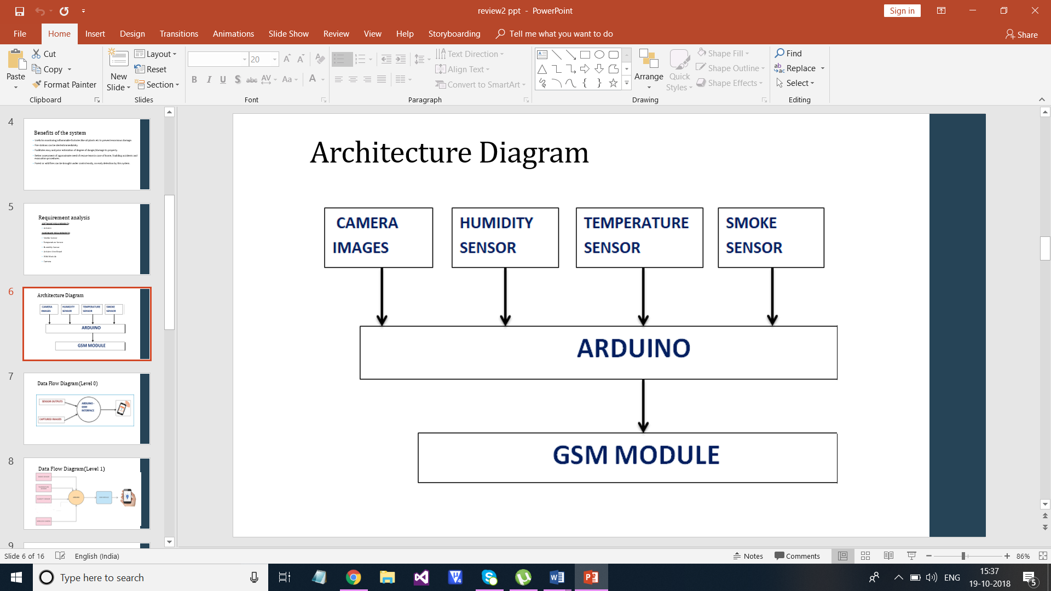

Fig.3.2.1: Basic Architecture of the Fire Detection System

**3.3 FLOW DIAGRAMS**

**DATA FLOW DIAGRAM (LEVEL 0)**

Fig.3.3.2

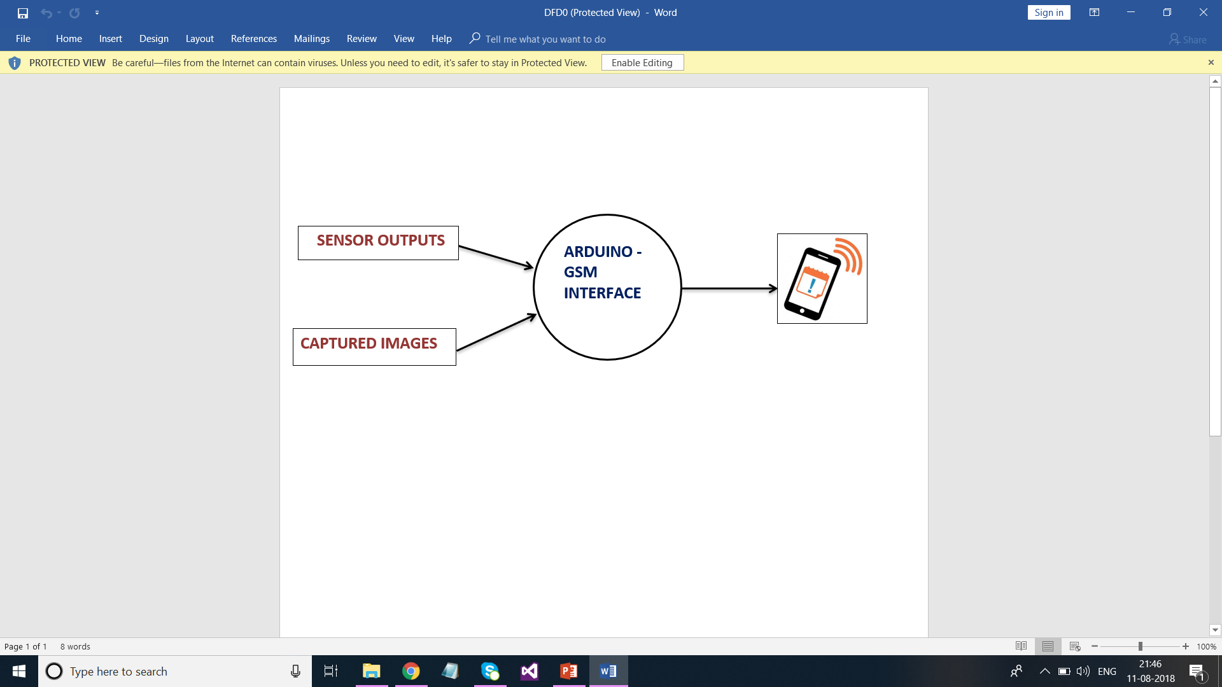

**DATA FLOW DIAGRAM (LEVEL 1)**

Fig.3.3.3



**CHAPTER 4**

**IMPLEMENTATION AND ANALYSIS**

**4.1 HARDWARE REQUIREMENTS**

• Arduino Uno Board

• Smoke Sensor

• Humidity Sensor

• Temperature Sensor

• GSM module (SIM900A)

• Jumpers

• OV7670 Camera module

1. **ARDUINO UNO:**

Arduino Uno is a microcontroller board based on the ATmega328. The ATmega328  is a single-[chip](https://en.wikipedia.org/wiki/Integrated_circuit) [microcontroller](https://en.wikipedia.org/wiki/Microcontroller) created by [Atmel](https://en.wikipedia.org/wiki/Atmel) in the [mega AVR](https://en.wikipedia.org/wiki/MegaAVR) family.

**Programming**

The Arduino/Genuino Uno can be programmed with the [Arduino Software](https://www.arduino.cc/en/Main/Software) (IDE). Select "Arduino/Genuino Uno from the Tools > Board menu (according to the microcontroller on your board). The ATmega328 on the Arduino/Genuino Uno comes preprogrammed with a [bootloader](https://www.arduino.cc/en/Hacking/Bootloader?from=Tutorial.Bootloader) that allows you to upload new code to it without the use of an external hardware programmer. It communicates using the original STK500 protocol.

**Power**

The Arduino/Genuino Uno board can be powered via the USB connection or with an external power supply. The power source is selected automatically. External (non-USB) power can come either from an AC-to-DC adapter (wall-wart) or battery.

**Power Pins:**

* **Vin:** The input voltage to the Arduino/Genuino board when it's using an external power source (as opposed to 5 volts from the USB connection or other regulated power source). You can supply voltage through this pin, or, if supplying voltage via the power jack, access it through this pin.
* **5V:** This pin outputs a regulated 5V from the regulator on the board. The board can be supplied with power either from the DC power jack (7 - 12V), the USB connector (5V), or the VIN pin of the board (7-12V). Supplying voltage via the 5V or 3.3V pins bypasses the regulator, and can damage your board. We don't advise it.
* **3.3V:** A 3.3 volt supply generated by the on-board regulator. Maximum current draw is 50 mA.
* **GND:** Ground pins.

**Memory**

The ATmega328 has 32 KB (with 0.5 KB occupied by the bootloader). It also has 2 KB of SRAM and 1 KB of EEPROM.

**Input and Output**

Each of the 14 digital pins on the Uno can be used as an input or output, using [pinMode()](https://www.arduino.cc/en/Reference/PinMode), [digitalWrite()](https://www.arduino.cc/en/Reference/DigitalWrite), and [digitalRead()](https://www.arduino.cc/en/Reference/DigitalRead) functions. They operate at 5 volts. Each pin can provide or receive 20 mA as recommended operating condition and has an internal pull-up resistor (disconnected by default) of 20-50k ohm. A maximum of 40mA is the value that must not be exceeded on any I/O pin to avoid permanent damage to the microcontroller.

**Special Functions of Pins:**

* **Serial:** 0 (RX) and 1 (TX). Used to receive (RX) and transmit (TX) TTL serial data. These pins are connected to the corresponding pins of the ATmega8U2 USB-to-TTL Serial chip.
* **External Interrupts:** 2 and 3. These pins can be configured to trigger an interrupt on a low value, a rising or falling edge, or a change in value. See the attachInterrupt() function for details.
* **PWM:** 3, 5, 6, 9, 10, and 11. Provide 8-bit PWM output with the analogWrite() function.
* **SPI:** 10 (SS), 11 (MOSI), 12 (MISO), 13 (SCK). These pins support SPI communication using the SPI library.
* **LED:** 13. There is a built-in LED driven by digital pin 13. When the pin is HIGH value, the LED is on, when the pin is LOW, it's off.
* **TWI:** A4 or SDA pin and A5 or SCL pin. Support TWI communication using the Wire library.

The Uno has 6 analog inputs, labeled A0 through A5, each of which provide 10 bits of resolution (i.e. 1024 different values). By default they measure from ground to 5 volts, though is it possible to change the upper end of their range using the AREF pin and the analogReference() function. There are a couple of other pins on the board.

* **AREF**: Reference voltage for the analog inputs. Used with analogReference().
* **Reset:** Bring this line LOW to reset the microcontroller. Typically used to add a reset button to shields which block the one on the board.

**Communication**

Arduino/Genuino Uno has a number of facilities for communicating with a computer, another Arduino/Genuino board, or other microcontrollers. The ATmega328 provides UART TTL (5V) serial communication, which is available on digital pins 0 (RX) and 1 (TX). An ATmega16U2 on the board channels this serial communication over USB and appears as a virtual com port to software on the computer. The 16U2 firmware uses the standard USB COM drivers, and no external driver is needed. However, [on Windows, a .inf file is required](https://www.arduino.cc/en/Guide/Windows#toc4). The Arduino Software (IDE) includes a serial monitor which allows simple textual data to be sent to and from the board. The RX and TX LEDs on the board will flash when data is being transmitted via the USB-to-serial chip and USB connection to the computer (but not for serial communication on pins 0 and 1).

A [Software Serial library](https://www.arduino.cc/en/Reference/SoftwareSerial) allows serial communication on any of the Uno's digital pins.

The ATmega328 also supports I2C (TWI) and SPI communication. The Arduino Software (IDE) includes a Wire library to simplify use of the I2C bus; see the [documentation](https://www.arduino.cc/en/Reference/Wire) for details. For SPI communication, use the [SPI library](https://www.arduino.cc/en/Reference/SPI).

**Automatic (Software) Reset**

Rather than requiring a physical press of the reset button before an upload, the Arduino/Genuino Uno board is designed in a way that allows it to be reset by software running on a connected computer. One of the hardware flow control lines (DTR) of the ATmega8U2/16U2 is connected to the reset line of the ATmega328 via a 100 nanofarad capacitor. When this line is asserted (taken low), the reset line drops long enough to reset the chip. The Arduino Software (IDE) uses this capability to allow you to upload code by simply pressing the upload button in the interface toolbar. This means that the bootloader can have a shorter timeout, as the lowering of DTR can be well-coordinated with the start of the upload.

This setup has other implications. When the Uno is connected to either a computer running Mac OS X or Linux, it resets each time a connection is made to it from software (via USB). For the following half-second or so, the bootloader is running on the Uno. While it is programmed to ignore malformed data (i.e. anything besides an upload of new code), it will intercept the first few bytes of data sent to the board after a connection is opened. If a sketch running on the board receives one-time configuration or other data when it first starts, make sure that the software with which it communicates waits a second after opening the connection and before sending this data.

The Uno board contains a trace that can be cut to disable the auto-reset. The pads on either side of the trace can be soldered together to re-enable it. It's labeled "RESET-EN". You may also be able to disable the auto-reset by connecting a 110 ohm resistor from 5V to the reset line.

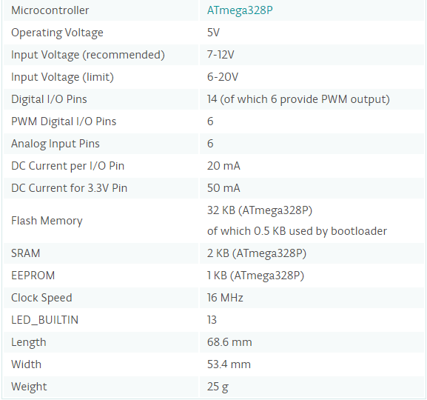

**5.3. SIM900A:**

The SIM900A is a complete Dual-band GSM/GPRS solution in a SMT module which can be embedded in the customer applications. Featuring an industry-standard interface, the SIM900A delivers GSM/GPRS 900/1800MHz performance for voice, SMS, Data, and Fax in a small form factor and with low power consumption. With a tiny configuration of 24mmx24mmx3mm, SIM900A can fit in almost all the space requirements in user applications, especially for slim and compact demand of design. The features of SIM900A are listed below.

* Dual-Band **900/ 1800 MHz**
* GPRS multi-slot class 10/8GPRS mobile station class B
* Compliant to GSM phase 2/2+Class 4 (2 W @850/ 900 MHz)
* **Class 1** (1 W @ 1800/1900MHz)
* Control via **AT commands** (GSM 07.07 ,07.05 and SIMCOM enhanced AT Commands)
* Low power consumption: **1.5mA(sleep mode)'**
* Operation temperature:**-40°C to +85 °C**
* **Status indicator(D5)**:It will flashes continuously whenever the call arrives otherwise it is left ON.
* **Network LED(D6)**:This led will blink every second which indicates that the GSM module is not connected to the mobile network. Once the connection is established successfully, the LED will blink continuously every 3 seconds.

**HOOKING THE SIM900A TO THE ARDUINO:**

The SIM900A module has 6pins in which two pins for Vcc and Gnd and the rest are 3VR&3VT(3volt Rx & Tx) and 5VR,5VT(5volt Rx & Tx) and the connections are made as follows:

|  |  |
| --- | --- |
| **SIM900A** | **ARDUINO UNO** |
| Vcc | 5V |
| GND | GND |
| 5VR | Pin 9 |
| 5VT | Pin 10 |

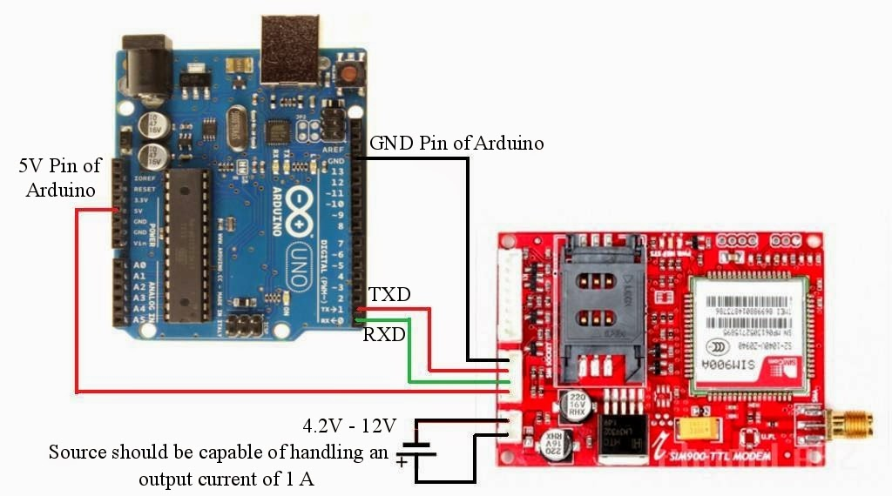

**4.2 SOFTWARE REQUIREMENTS**

* 1. **Arduino IDE:**

A program for Arduino may be written in any [programming language](https://en.wikipedia.org/wiki/Programming_language) for a compiler that produces binary machine code for the target processor. Atmel provides a development environment for their microcontrollers, AVR Studio and the newer Atmel Studio. The Arduino project provides the Arduino [integrated development environment](https://en.wikipedia.org/wiki/Integrated_development_environment) (IDE), which is a [cross-platform](https://en.wikipedia.org/wiki/Cross-platform) application written in the programming language [Java](https://en.wikipedia.org/wiki/Java_(programming_language)). It originated from the IDE for the languages [Processing](https://en.wikipedia.org/wiki/Processing_(programming_language)) and [Wiring](https://en.wikipedia.org/wiki/Wiring_(development_platform)). It includes a code editor with features such as text cutting and pasting, searching and replacing text, automatic indenting, [brace matching](https://en.wikipedia.org/wiki/Brace_matching), and [syntax highlighting](https://en.wikipedia.org/wiki/Syntax_highlighting), and provides simple one-click mechanisms to compile and upload programs to an Arduino board. It also contains a message area, a text console, a toolbar with buttons for common functions and a hierarchy of operation menus.

A program written with the IDE for Arduino is called a sketch. Sketches are saved on the development computer as text files with the file extension .ino. Arduino Software (IDE) pre-1.0 saved sketches with the extension .pde.

The Arduino IDE supports the languages [C](https://en.wikipedia.org/wiki/C_(programming_language)) and [C++](https://en.wikipedia.org/wiki/C%2B%2B) using special rules of code structuring. The Arduino IDE supplies a [software library](https://en.wikipedia.org/wiki/Software_library) from the [Wiring](https://en.wikipedia.org/wiki/Wiring_(development_platform)) project, which provides many common input and output procedures. User-written code only requires two basic functions, for starting the sketch and the main program loop, that are compiled and linked with a program stub main() into an executable [cyclic executive](https://en.wikipedia.org/wiki/Cyclic_executive) program with the [GNU toolchain](https://en.wikipedia.org/wiki/GNU_toolchain), also included with the IDE distribution. The Arduino IDE employs the program avr to convert the executable code into a text file in hexadecimal encoding that is loaded into the Arduino board by a loader program in the board's firmware.

A minimal Arduino C/C++ sketch, as seen by the Arduino IDE programmer, consists of only two functions.

* setup: This function is called once when a sketch starts after power-up or reset. It is used to initialize variables, input and output pin modes, and other libraries needed in the sketch.
* loop: After setup has been called, function loop is executed repeatedly in the main program. It controls the board until the board is powered off or is reset.

Most Arduino boards contain a [light-emitting diode](https://en.wikipedia.org/wiki/Light-emitting_diode) (LED) and a load resistor connected between pin 13 and ground, which is a convenient feature for many tests and program functions.

**4.3 RESULTS:**

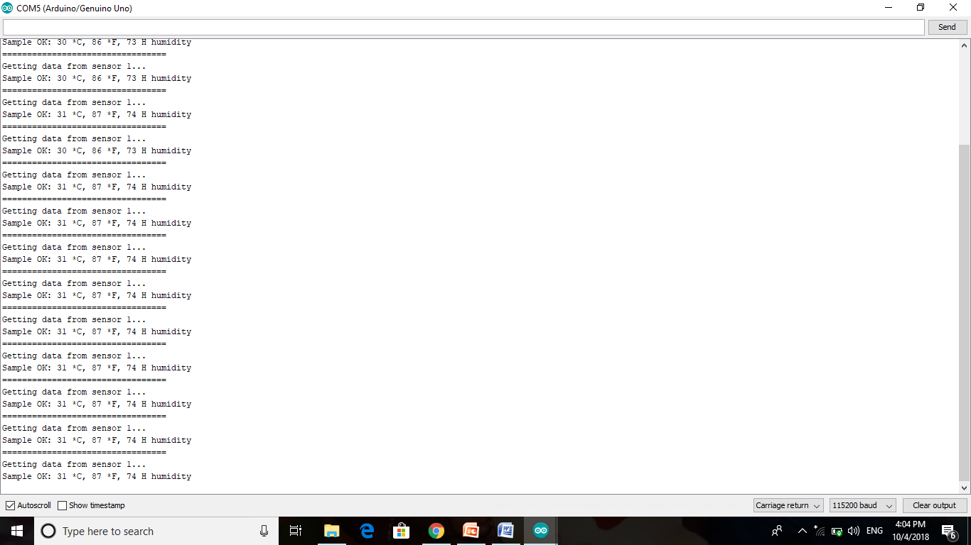

Fig 4.3.1 Output sample from DHT11 sensor

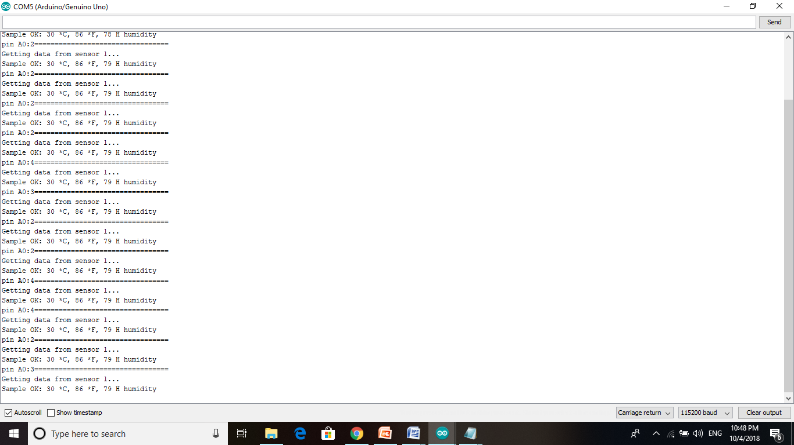

Fig 4.3.2 Output sample from DHT11, MQ2 interface

**CHAPTER 5**

**CONCLUSION AND FUTURE WORK**

This system presented the development of a fire alarm system using the Arduino UNO. This system undoes the need of a person to continuously monitor the area. The monitoring will be done with the help of sensors. Buzzer and Message alerts are used to alert the required authorities. This system is a low cost, power efficient and based on the instruments that reliable as well as durable. Many future works are also possible in this system design. We can use the multiple nodes for a single receiver node. GPS module could also be used to pin point the exact position of the fire. We can use the wind sensor to determine the rate of fire flow and its direction. Automated fire extinguishing system could be used along with the system. This system is developed to implement the knowledge gained during the engineering program.

**REFERENCES:**

1. A.Kultunov “Early fire detection using non-linear multitemporal prediction of thermal imagery”, 2007.
2. [Bo-Ho Cho](https://ieeexplore.ieee.org/search/searchresult.jsp?searchWithin=%22First%20Name%22:%22Bo-Ho%22&searchWithin=%22Last%20Name%22:%22Cho%22&newsearch=true), Jong-Wook Bae[Sung-Hwan Jung](https://ieeexplore.ieee.org/search/searchresult.jsp?searchWithin=%22First%20Name%22:%22Sung-Hwan%22&searchWithin=%22Last%20Name%22:%22Jung%22&newsearch=true) “Image Processing-Based Fire Detection System Using Statistic Color Model”, 2008.
3. [Byoung Chul Ko](https://www.sciencedirect.com/science/article/pii/S0379711208000957#!) , [Kwang-Ho Cheong](https://www.sciencedirect.com/science/article/pii/S0379711208000957" \l "!) and [Jae-Yeal Nam](https://www.sciencedirect.com/science/article/pii/S0379711208000957#!) “Fire detection based on vision sensor and support vector machines”, 2008.
4. [C. L. Lai](https://ieeexplore.ieee.org/search/searchresult.jsp?searchWithin=%22First%20Name%22:%22C.%20L.%22&searchWithin=%22Last%20Name%22:%22Lai%22&newsearch=true), [J. C. Yang](https://ieeexplore.ieee.org/search/searchresult.jsp?searchWithin=%22First%20Name%22:%22J.%20C.%22&searchWithin=%22Last%20Name%22:%22Yang%22&newsearch=true), [Y. H. Chen](https://ieeexplore.ieee.org/search/searchresult.jsp?searchWithin=%22First%20Name%22:%22Y.%20H.%22&searchWithin=%22Last%20Name%22:%22Chen%22&newsearch=true) “A Real Time Video Processing Based Surveillance System for Early Fire”, 2007.
5. [Ferry Astika Saputra](https://ieeexplore.ieee.org/search/searchresult.jsp?searchWithin=%22First%20Name%22:%22Ferry%20Astika%22&searchWithin=%22Last%20Name%22:%22Saputra%22&newsearch=true), [M. Udin Harun Al Rasyid](https://ieeexplore.ieee.org/search/searchresult.jsp?searchWithin=%22First%20Name%22:%22M.%20Udin%20Harun%20Al%22&searchWithin=%22Last%20Name%22:%22Rasyid%22&newsearch=true) [Bey Aryo Abiantoro](https://ieeexplore.ieee.org/search/searchresult.jsp?searchWithin=%22First%20Name%22:%22Bey%20Aryo%22&searchWithin=%22Last%20Name%22:%22Abiantoro%22&newsearch=true) “Prototype of early fire detection system for home monitoring based on Wireless Sensor Network”,2017.
6. [Jaime Lloret](https://www.mdpi.com/search?authors=Jaime%20Lloret&orcid=0000-0002-0862-0533) , [Miguel Garcia](https://www.mdpi.com/search?authors=Miguel%20Garcia&orcid=) “A Wireless Sensor Network Deployment for Rural and Forest Fire Detection and Verification”, 2009.
7. [Junguo Zhang](https://ieeexplore.ieee.org/search/searchresult.jsp?searchWithin=%22First%20Name%22:%22Junguo%22&searchWithin=%22Last%20Name%22:%22Zhang%22&newsearch=true), [Wenbin Li](https://ieeexplore.ieee.org/search/searchresult.jsp?searchWithin=%22First%20Name%22:%22Wenbin%22&searchWithin=%22Last%20Name%22:%22Li%22&newsearch=true) “Forest fire detection system based on wireless sensor network”, 2009
8. [Leonardo Millan-Garcia](https://www.ncbi.nlm.nih.gov/pubmed/?term=Millan-Garcia%20L%5BAuthor%5D&cauthor=true&cauthor_uid=22778607), [Gabriel Sanchez-Perez](https://www.ncbi.nlm.nih.gov/pubmed/?term=Sanchez-Perez%20G%5BAuthor%5D&cauthor=true&cauthor_uid=22778607) “An Early Fire Detection Algorithm Using IP Cameras”, 2012.
9. [Suchet Rinsurongkawong](https://ieeexplore.ieee.org/search/searchresult.jsp?searchWithin=%22First%20Name%22:%22Suchet%22&searchWithin=%22Last%20Name%22:%22Rinsurongkawong%22&newsearch=true),[Mongkol Ekpanyapong](https://ieeexplore.ieee.org/search/searchresult.jsp?searchWithin=%22First%20Name%22:%22Mongkol%22&searchWithin=%22Last%20Name%22:%22Ekpanyapong%22&newsearch=true), [Matthew N. Dailey](https://ieeexplore.ieee.org/search/searchresult.jsp?searchWithin=%22First%20Name%22:%22Matthew%20N.%22&searchWithin=%22Last%20Name%22:%22Dailey%22&newsearch=true) “Fire detection for early fire alarm based on optical flow video processing”, 2012.
10. [Susan LRose-Pehrsson](https://www.sciencedirect.com/science/article/pii/S0925400500004810#!) , [Ronald EShaffer](https://www.sciencedirect.com/science/article/pii/S0925400500004810#!) , [Scott AHill](https://www.sciencedirect.com/science/article/pii/S0925400500004810#!) “Multi-criteria fire detection systems using a probabilistic neural network”, 2000.